RESOLUTION NO.__________

RE: CERTIFICATE OF APPROPRIATENESS UNDER THE
PROVISIONS OF THE ACT OF THE PENNSYLVANIA
LEGISLATURE 1961, JUNE 13, P.L. 282 (53
SECTION 8004) AND BETHLEHEM ORDINANCE NO.
3952 AS AMENDED.

WHEREAS, it is proposed to replace the roof at 438 High Street.

NOW, THEREFORE, BE IT RESOLVED by the Council of the City of Bethlehem that a Certificate of Appropriateness is hereby granted for the proposal.

Sponsored by: (s)

(s)

ADOPTED BY COUNCIL THIS DAY OF 2016

(s)
President of Council

ATTEST:

(s)
City Clerk

HISTORICAL & ARCHITECTURAL REVIEW BOARD

The applicant is proposing to replace the roof at 438 High Street.
APPLICATION #:

Alan & Patricia Lowcher
438 High Street
Bethlehem, PA 18018

OWNER:

__________________________________________________________________________

The Board upon motion by Nancy Shelly and seconded by Marsha Fritz adopted the proposal that City Council issue a Certificate of Appropriateness for the following:

- The approved shingle color will be Antique Slate Gray.

- Chimney flashings are to be lead coated copper metal or copper material.

- Valleys to be same material as chimney flashings.

- Drip edge to be same color as white trim.

5. The motion was unanimously approved.
__________________________________________________________________________

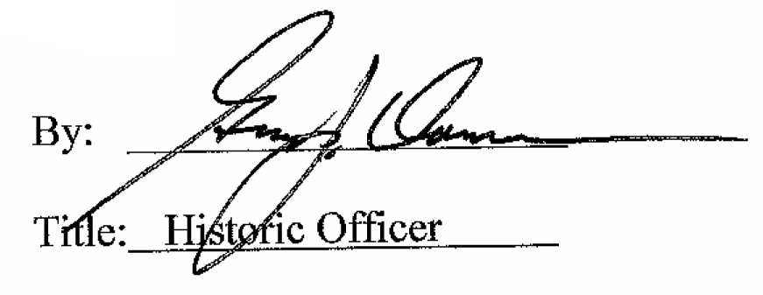

Date of Meeting: October 5, 2016

